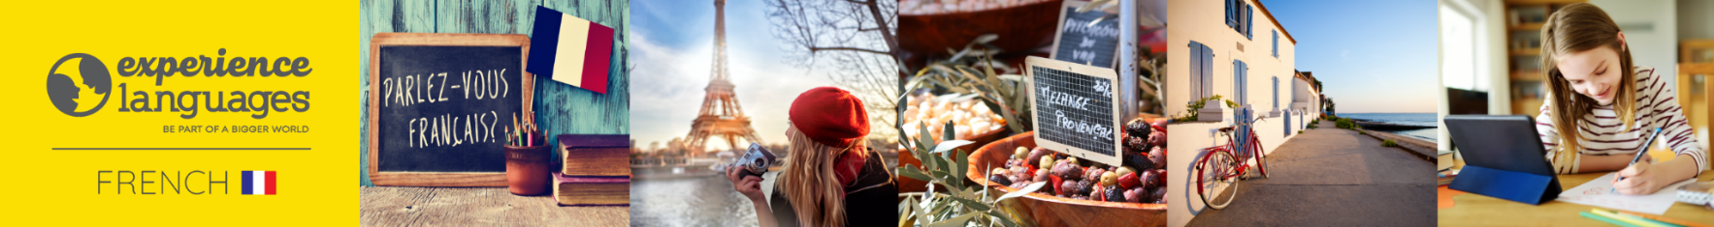

visit www.experiencelanguages.co.uk for more information about classes for children and adults.

FRENCH CLUB
FOR RECEPTION, YEAR 1 and YEAR 2 CHILDREN

Dear parents,

At after school French Club, your child will be learning French through fun, engaging, and age-appropriate activities such as roleplays, singing, rhymes, games and stories. These activities aim primarily at enhancing children's speaking and listening skills. With regular, enjoyable exposure and a focus on listening and speaking, your child will begin to recognise and use French words and phrases with ease.

At the start of term, parents will receive an overview of what their children will be learning, and older pupils will take part in reading and writing activities to help consolidate their understanding.

Afterschool sessions will start on Thursday 15 January and end Thursday 19 March and will take place between 15.30 and 16.30.

Each session costs £10.50 and therefore the cost for the autumn term is £94.5 (£10.50 x 9 weeks).

If your child would like to start / continue learning French in the autumn term, I would be grateful if you could confirm by emailing me at christele@experiencelanguages.co.uk.

Should you require more information please do not hesitate to contact me directly on 07429 477 008.

Kind regards

Christèle
visit www.experiencelanguages.co.uk for more information about classes for children and adults.

PAYMENTS

For bank transfers, please find account details below (please use your child's name as reference). Payments should be made before the start of term i.e. by Thursday 15 January at the latest.

Name: Christele Annis
Bank: Halifax
Sort code: 11-18-11
Account number: 22453039

