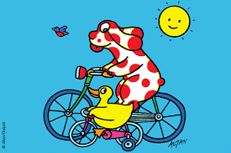

18th March 2026

ITALIAN Language Club

Dear Parents,

I am very happy to announce that I will continue teaching my beautiful language at the Alban City School.

For children in KS1 and KS2 the club will run during lunch break on Mondays for eleven weeks as follows:
20/4 – 27/4 – 05/5 – 11/05 – 18/05 – 01/06 – 08/06 – 15/06 – 22/06 – 29/06 – 06/07

The cost for the eleven weeks will be £55.

Please note that I need a minimum number of 10 children per class in order to run the club.

If your child is interested in joining the club, I would appreciate if you could send me an email with the following details by Friday the 10th of April:

Child’s Name: ___________________________ Year and Class: ____________________

Once I know the number of children interested, I will make up the classes and get back to you with the timetable.

Children will learn the Italian language through activities, songs and stories and will also learn about Italian culture.
Many thanks.
Yours sincerely,

Cinzia Gallo – Teacher
Cinzia.gallo01@gmail.com

